# Project Design Phase-II

# Technology Stack (Architecture & Stack)

|  |  |
| --- | --- |
| **Date** | 20 October 2022 |
| **Team ID** | PNT2022TMID02412 |
| **Project Name** | Gas Leakage and Monitoring and alerting system |
| **Maximum Marks** | 4 Marks |

**Technical Architecture:**

# The deliverable must include the architectural diagram shown below as well as the information shown in tables 1 and 2.

# Example: Order processing in offline mode during pandemics

**Table-1: Components & Technologies:**

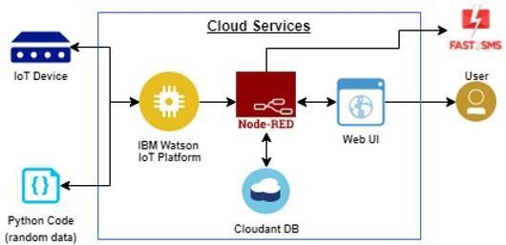

|  |  |  |  |
| --- | --- | --- | --- |
| **S. No** | **Component** | **Description** | **Technology** |
| 1. | User Interface | The user can view information about our company and our manufacturing rate. And the user can learn about our product's features, benefits, and drawbacks of the company's operations without our product. The user can learn all there is to know about our products as well as our regular services, discounts, and warranties as well as our replacement procedures. Additionally, the viewer can view each product's profit flowchart. and the user can view the order tracking information. | HTML, CSS, JavaScript |
| 2. | Application Logic-1 | Logic for an application procedure. | Java / Python / C# |
| 3. | Application Logic-2 | A process's reasoning in the application | IBM Watson STT service |
| 4. | Application Logic-3 | A process's reasoning in the application | IBM Watson Assistant |
| 5. | Database | Data Type, Configurations… | MySQL, NoSQL… |
| 6. | Cloud Database | Cloud database service | IBM DB2, IBM Cloudant… |
| 7. | File Storage | Storage needs for files | IBM Block Storage, another storage service, or the local filesystem. |

|  |  |  |  |
| --- | --- | --- | --- |
| 8. | External API-1 | Purpose of External API used in the  application | IBM Weather API… |
| 9. | External API-2 | Purpose of External API used in the  application | Aadhar API… |
| 10. | Machine Learning Model | Purpose of Machine Learning Model | Object Recognition Model, etc. |
| 11. | Infrastructure (Server / Cloud) | Local System Deployment / Cloud Local Server Configuration: Cloud Server Configuration | Local, Cloud Foundry, Kubernetes, and so on. |

**Table-2: Application Characteristics:**

|  |  |  |  |
| --- | --- | --- | --- |
| **S. No** | **Characteristics** | **Description** | **Technology** |
| 1. | Open-Source Frameworks | “.Net” | “.Net framework (4.7.2) |
| 2. | Security Implementations | The gas monitoring system provides the customer with high-level security and safety. They keep an eye on the gas lines to see if there are any leaks. When a gas leak occurs, the works and the entire industry are notified. As a result, the gas pipe can be turned off by the workers. As a result, they can disregard the gas flow in pipes, which prevents the spread of gas in industry. | SHA-256, Encryptions, IAM Controls, OWASP, and so on. |

|  |  |  |  |
| --- | --- | --- | --- |
| 3. | Scalable Architecture | Every type of gas can be detected by the gas detection system. It can also measure gas at any concentration level. It can also measure the gas in small quantities. This ensures that the industry is safe and secure. It is also a form of prevention. | Technology used |
| 4. | Availability | Every day, our product will be available. And the sensors can detect any gas leaks. As a result, our product is inexpensive. The customer is not required to install sensors for each and every type of gas.  Several sensors are embedded in the product. It is also available at reasonable prices. | Technology used |
| 5. | Performance | Our product will deliver excellent results. If it is properly maintained and serviced. The gas leakage monitoring system will be operational 24 hours a day, seven days a week. It monitors gas pipe lines and has a 99.9% accuracy in detecting gas leakage. The performance will be satisfactory if it is properly maintained and serviced. | Technology used |